LOGIN

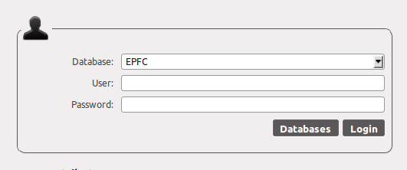
Sample Login screeenshot

Information to fill:

Database
  - select from the dropdown box the database you are going to use.
User
  - input the user id given to you by your administrator.
Password
  - input your password.

Click login button to access the contents of the system.

Error Messages:
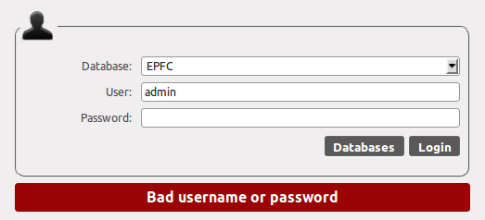
Sample error message.

This error message will appear either you incorrectly type your user id and password.

